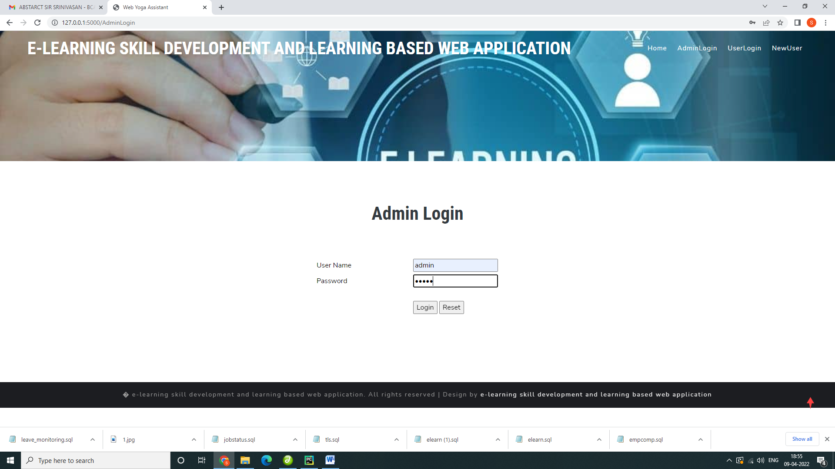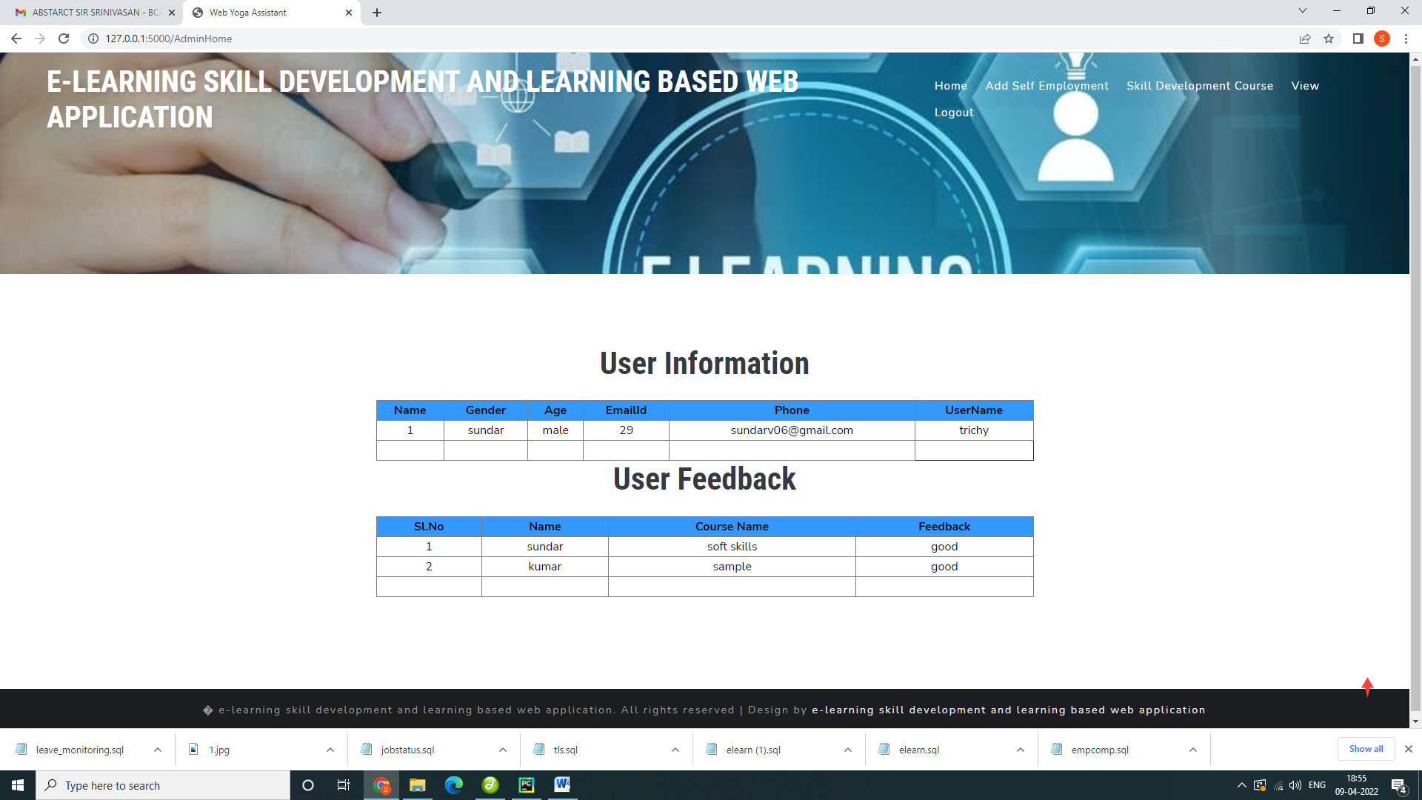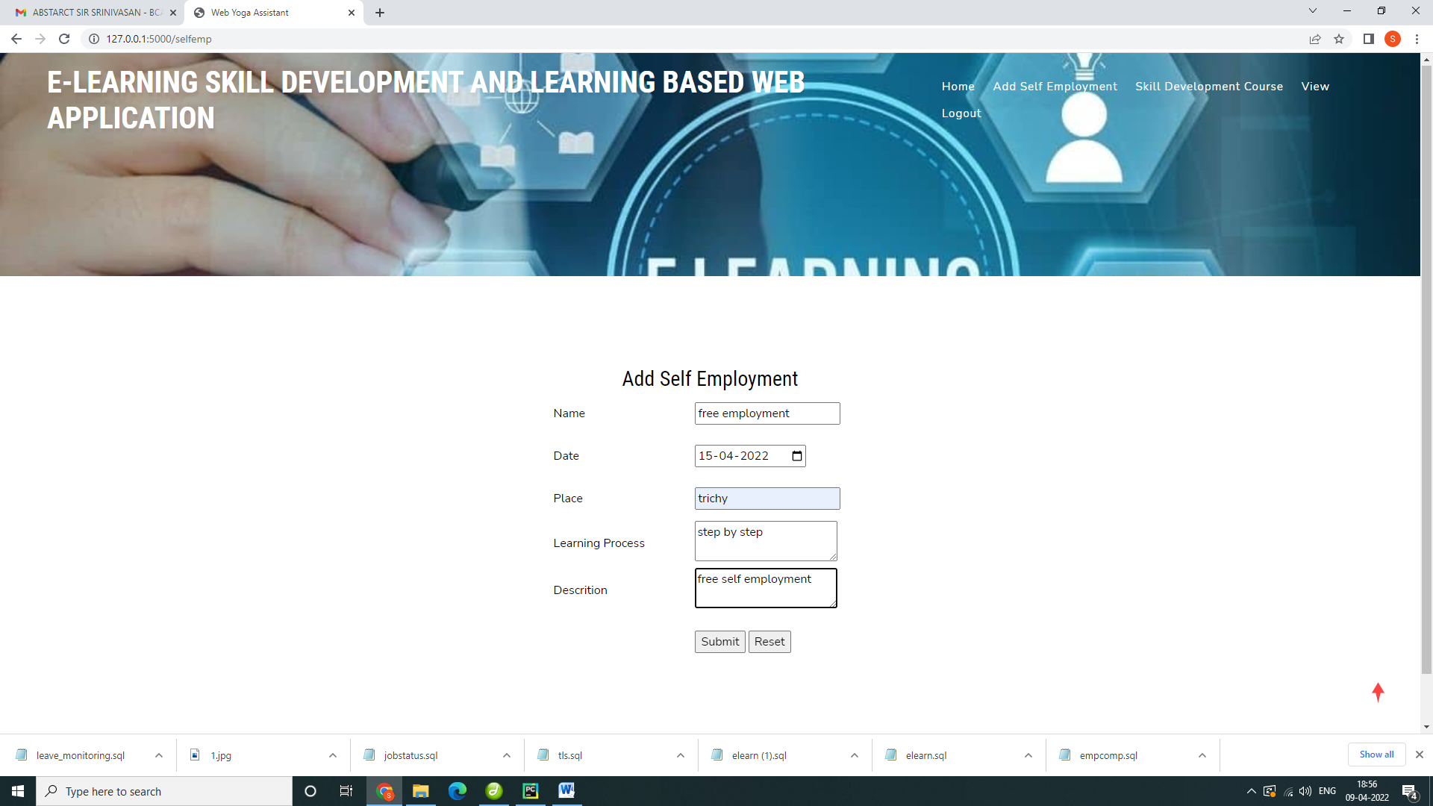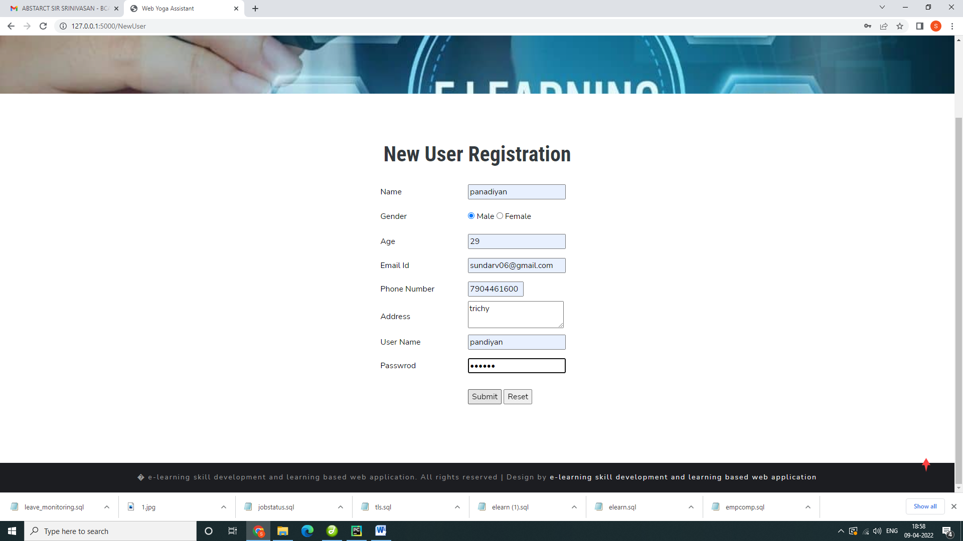

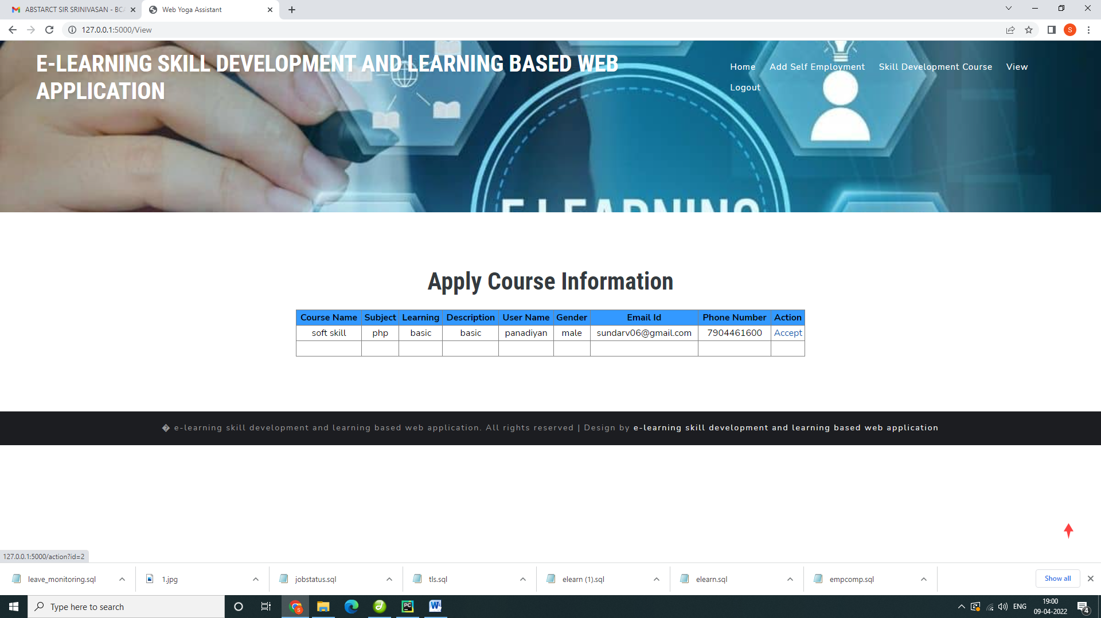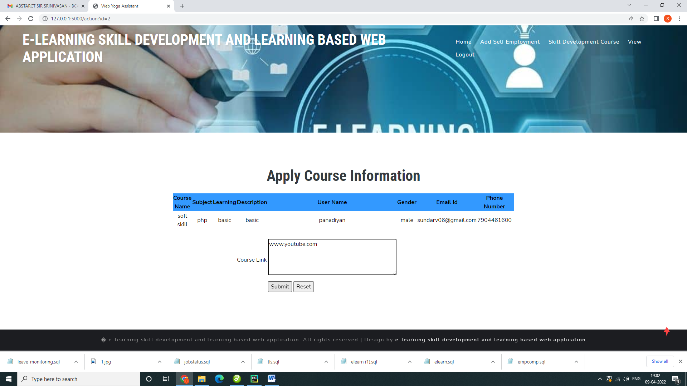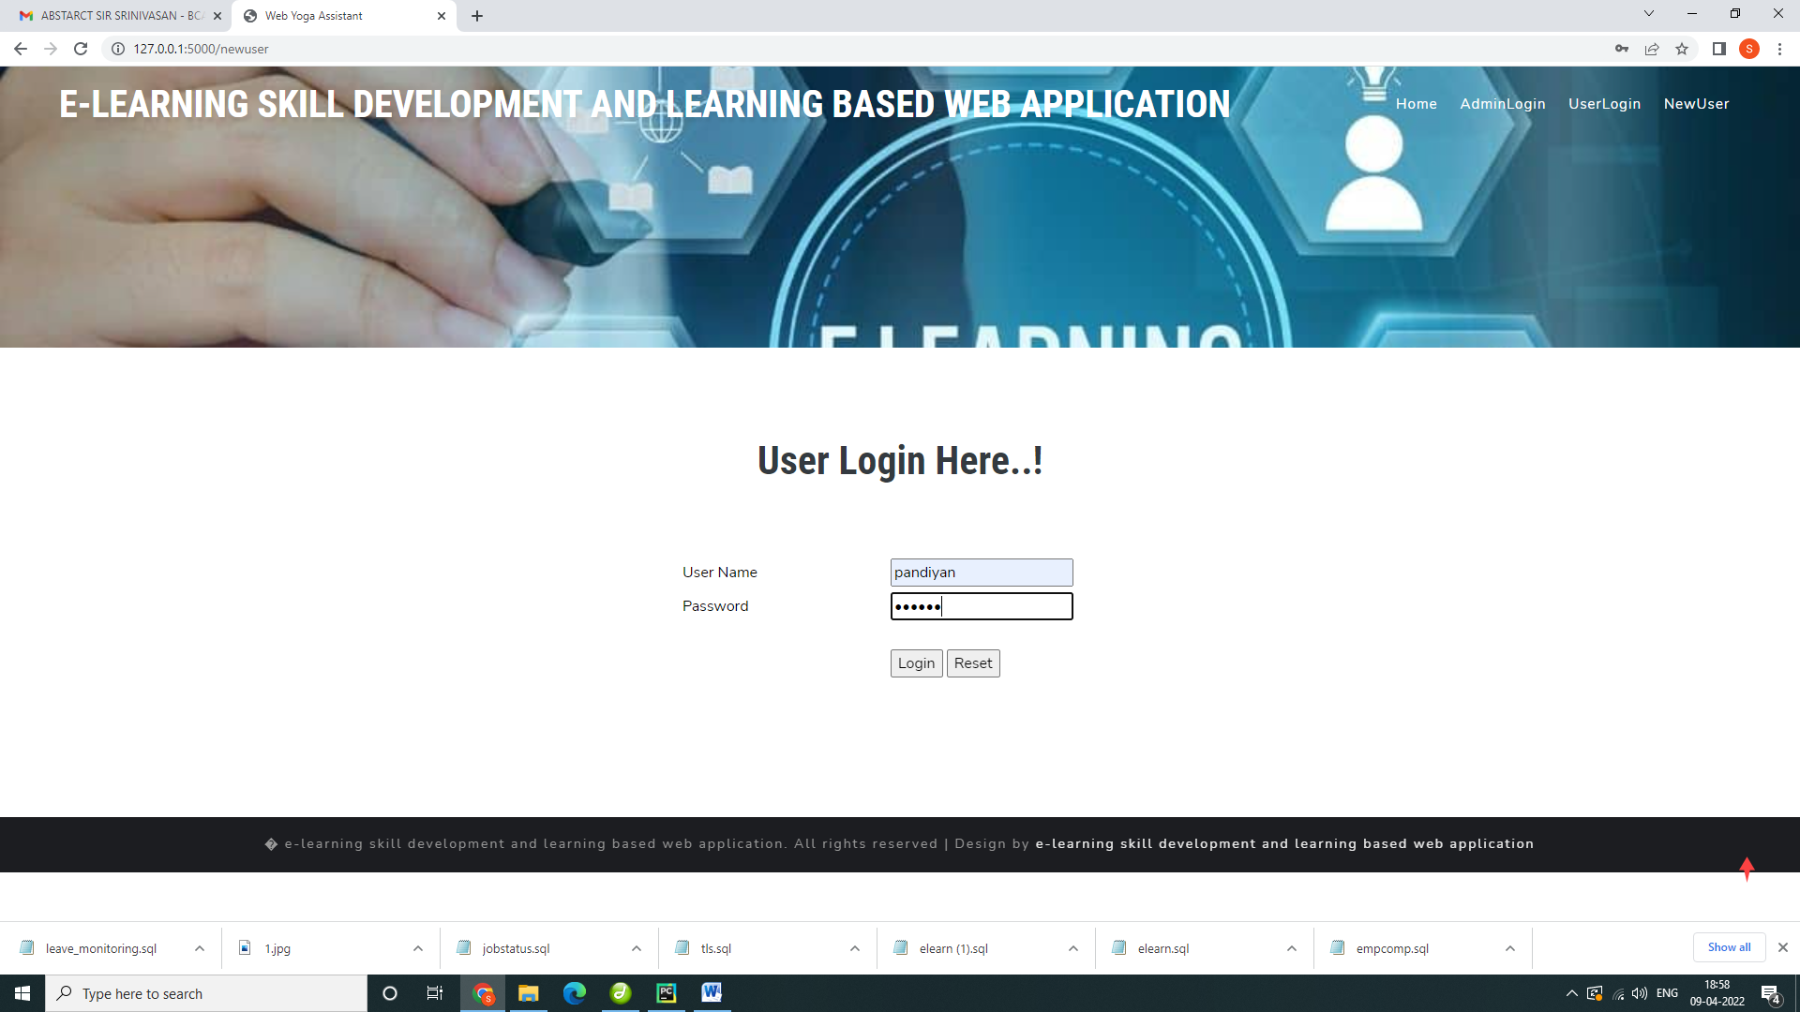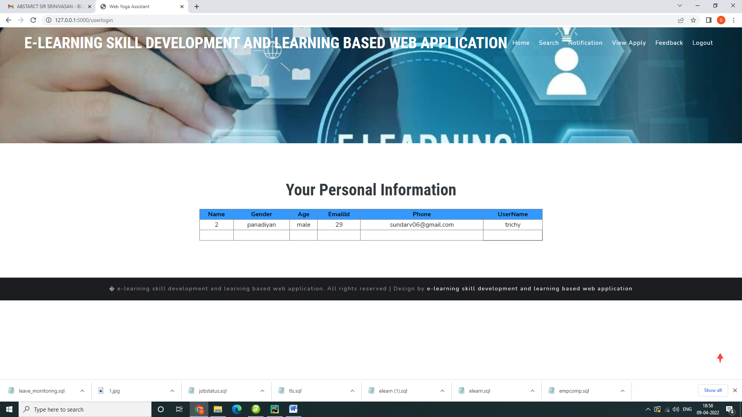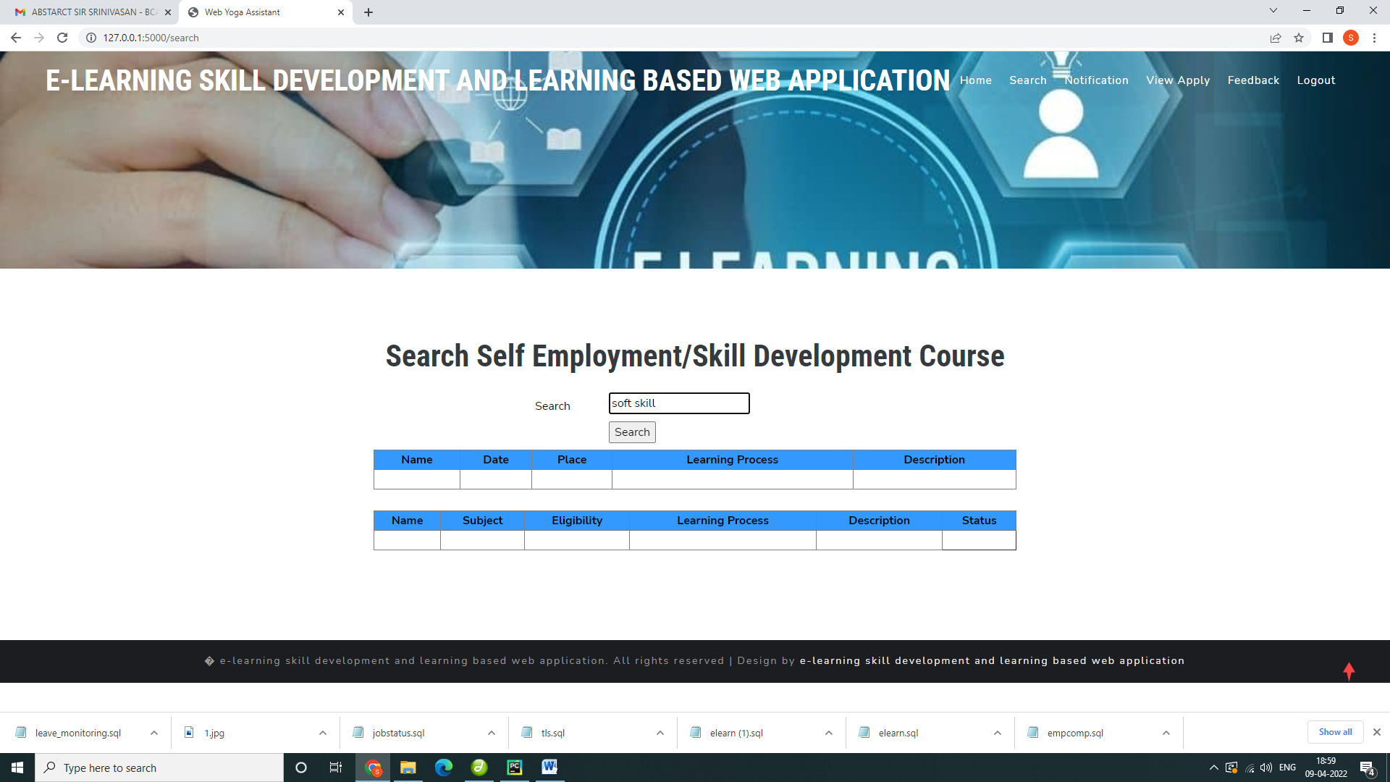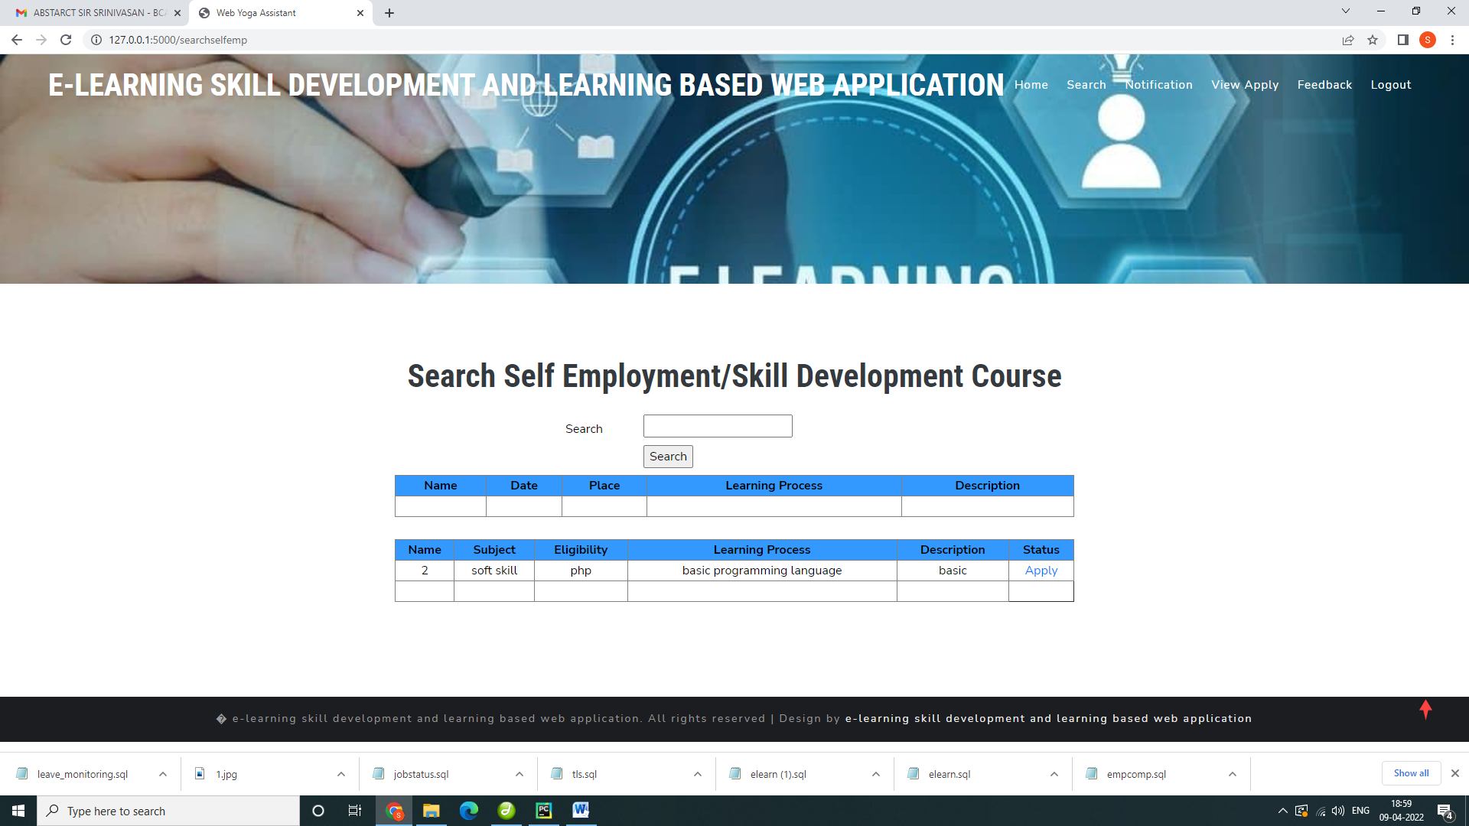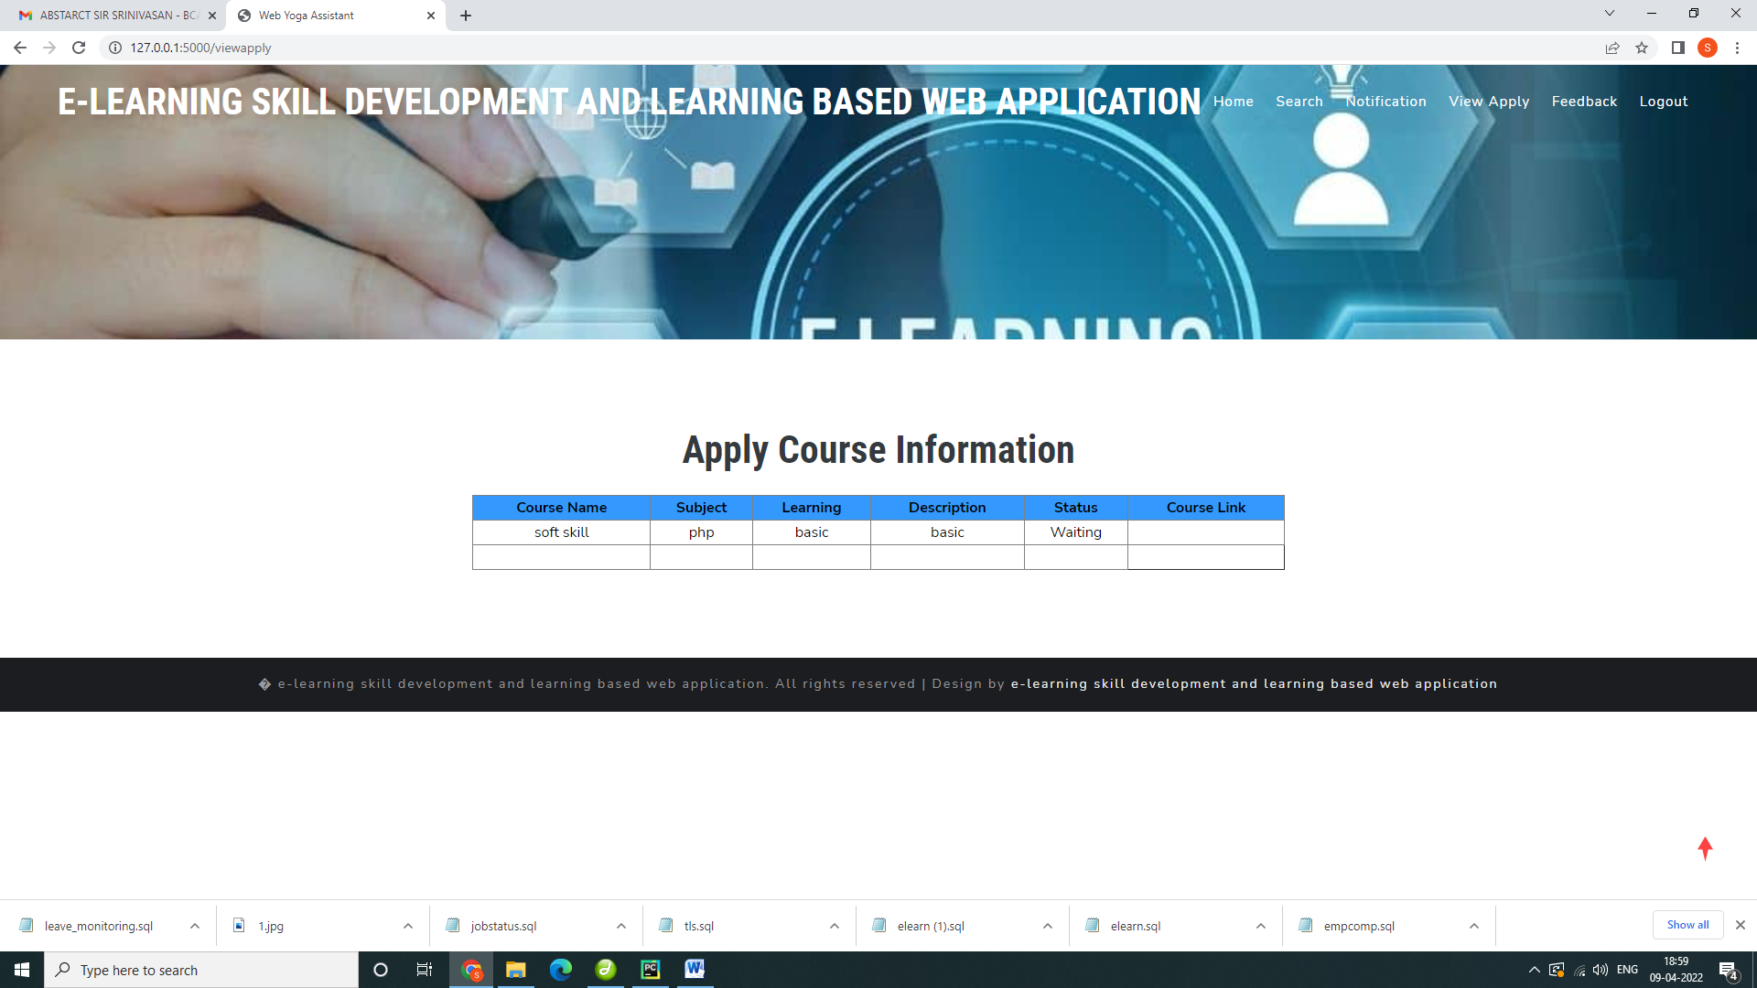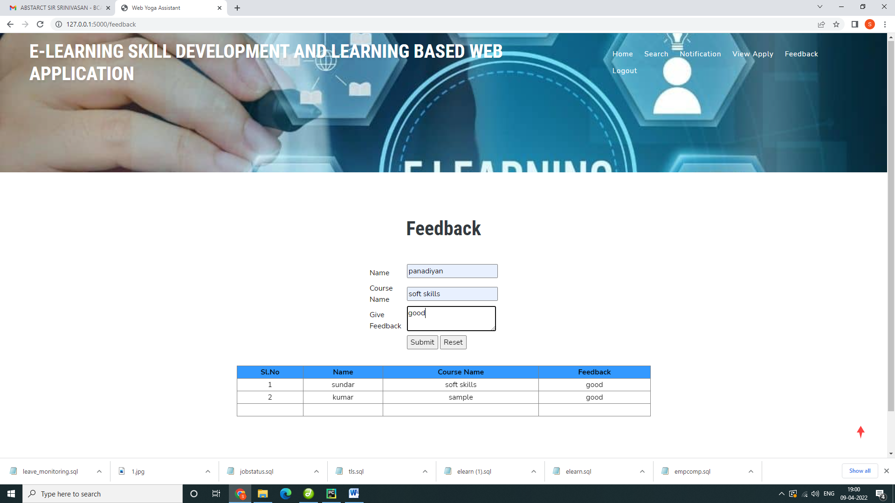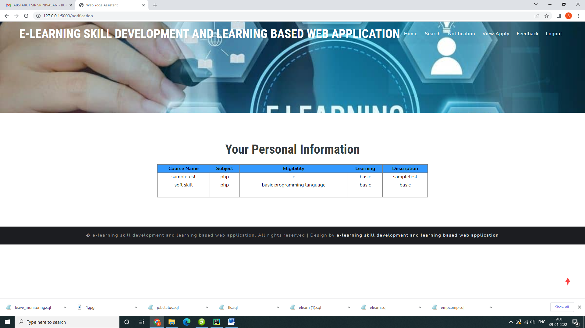

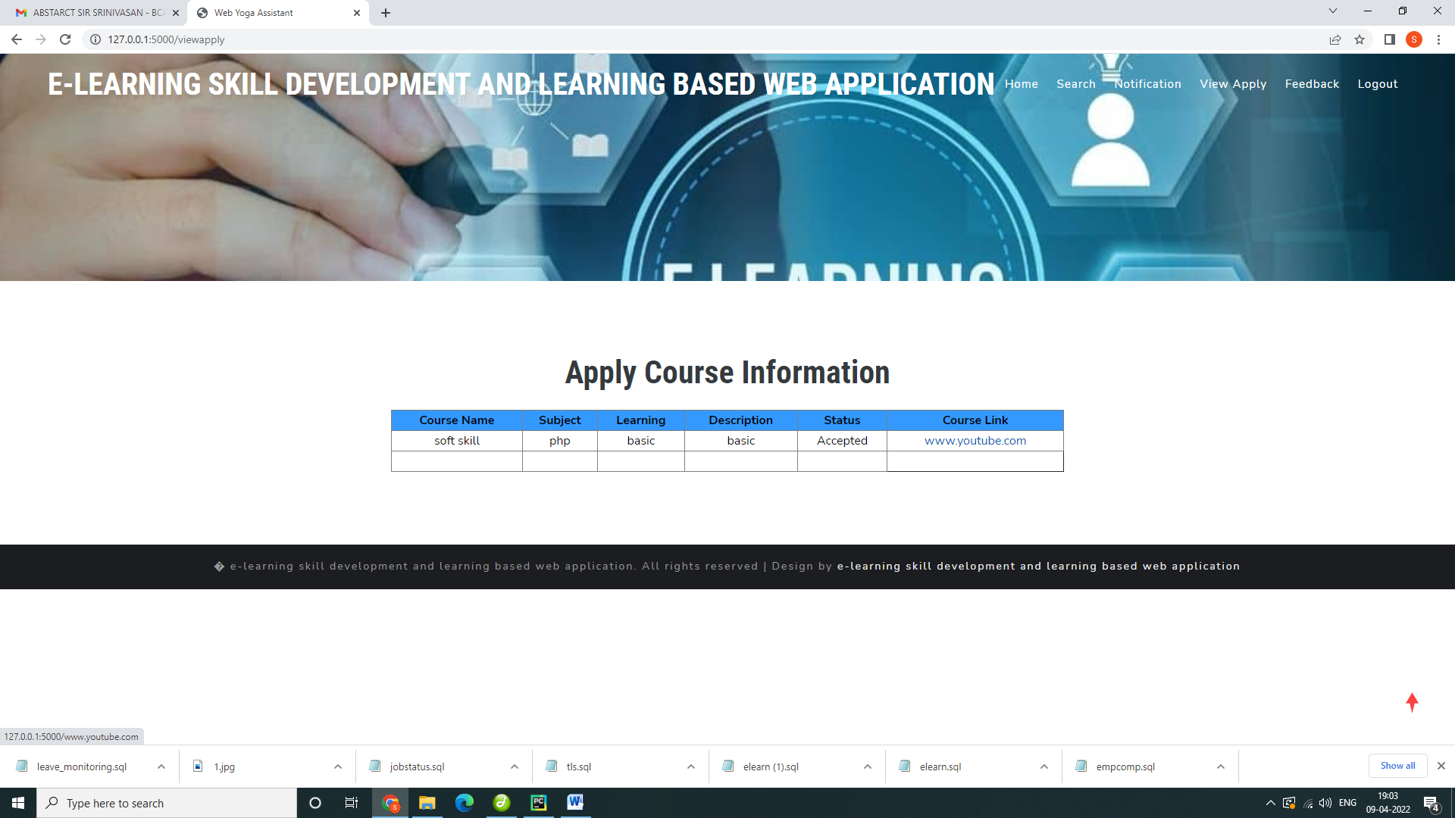

Python Code

**from** flask **import** Flask, render_template, flash, request, session  
**from** flask **import** render_template, redirect, url_for, request  
*#from wtforms import Form, TextField, TextAreaField, validators, StringField, SubmitField  
#from werkzeug.utils import secure_filename***import** mysql.connector  
**import** smtplib  
  
  
  
app = Flask(__name__)  
app.config.from_object(__name__)  
app.config[**'SECRET_KEY'**] = **'7d441f27d441f27567d441f2b6176a'**app.config[**'DEBUG'**]  
  
  
@app.route(**"/"**)  
**def** homepage():  
 **return** render_template(**'index.html'**)  
@app.route(**"/Home"**)  
**def** Home():  
 **return** render_template(**'index.html'**)  
  
  
@app.route(**"/AdminLogin"**)  
**def** AdminLogin():  
 **return** render_template(**'AdminLogin.html'**)  
  
@app.route(**"/adminlogin"**, methods=[**'GET'**, **'POST'**])  
**def** adminlogin():  
 error = **None  
 if** request.method == **'POST'**:  
 **if** request.form[**'uname'**] == **'admin' or** request.form[**'password'**] == **'admin'**:  
 conn = mysql.connector.connect(user=**'root'**, password=**''**, host=**'localhost'**, database=**'elearn'**)  
 cursor = conn.cursor()  
 cur = conn.cursor()  
 cur.execute(**"SELECT * FROM regtb"**)  
 data = cur.fetchall()  
 **return** render_template(**'AdminHome.html'**, data=data)  
  
 **else**:  
 **return** render_template(**'index.html'**, error=error)  
  
@app.route(**"/AdminHome"**)  
**def** AdminHome():  
 conn = mysql.connector.connect(user=**'root'**, password=**''**, host=**'localhost'**, database=**'elearn'**)  
 *# cursor = conn.cursor()* cur = conn.cursor()  
 cur.execute(**"SELECT * FROM regtb"**)  
 data = cur.fetchall()  
 cur1 = conn.cursor()  
 cur1.execute(**"SELECT * FROM feedback"**)  
 data1 = cur1.fetchall()  
 **return** render_template(**'AdminHome.html'**, data=data,data1=data1)  
  
@app.route(**"/selfemp"**)  
**def** selfemp():  
 **return** render_template(**'addselfemp.html'**)  
  
@app.route(**"/development"**)  
**def** development():  
 **return** render_template(**'development.html'**)  
  
@app.route(**"/View"**)  
**def** View():  
 conn = mysql.connector.connect(user=**'root'**, password=**''**, host=**'localhost'**, database=**'elearn'**)  
 cursor11 = conn.cursor()  
 cursor11.execute(**"select * from apply where status='Waiting'"**)  
 data11 = cursor11.fetchall()  
  
 **return** render_template(**"view.html"**, data=data11)  
  
 *#return render_template('view.html')*@app.route(**"/addselfemp"**, methods=[**'GET'**, **'POST'**])  
**def** addselfemp():  
 **if** request.method == **'POST'**:  
  
 name = request.form[**'name'**]  
 date = request.form[**'date'**]  
 place = request.form[**'place'**]  
 learning = request.form[**'learning'**]  
 description = request.form[**'description'**]  
  
  
  
 conn = mysql.connector.connect(user=**'root'**, password=**''**, host=**'localhost'**, database=**'elearn'**)  
 cursor = conn.cursor()  
 cursor.execute(  
 **"INSERT INTO selfemp VALUES ('','"** + name + **"','"** + date + **"','"** + place + **"','"** + learning + **"','"** + description + **"')"**)  
 conn.commit()  
 conn.close()  
 *# return 'file register successfully'* **return** render_template(**'addselfemp.html'**)  
@app.route(**"/addcourse"**, methods=[**'GET'**, **'POST'**])  
**def** addcourse():  
 **if** request.method == **'POST'**:  
  
 name = request.form[**'name'**]  
 date = request.form[**'sub'**]  
 place = request.form[**'elg'**]  
 learning = request.form[**'learning'**]  
 description = request.form[**'description'**]  
  
  
  
 conn = mysql.connector.connect(user=**'root'**, password=**''**, host=**'localhost'**, database=**'elearn'**)  
 cursor = conn.cursor()  
 cursor.execute(  
 **"INSERT INTO course VALUES ('','"** + name + **"','"** + date + **"','"** + place + **"','"** + learning + **"','"** + description + **"')"**)  
 conn.commit()  
 conn.close()  
 *# return 'file register successfully'* **return** render_template(**'development.html'**)  
@app.route(**"/searchselfemp"**, methods=[**'GET'**, **'POST'**])  
**def** searchselfemp():  
 **if** request.method == **'POST'**:  
  
 name = request.form[**'sname'**]  
 *#cname= request.form['cname']* conn = mysql.connector.connect(user=**'root'**, password=**''**, host=**'localhost'**, database=**'elearn'**)  
 cursor = conn.cursor()  
 cursor.execute(**"SELECT * from selfemp where name='"** + name + **"'"**)  
 data = cursor.fetchone()  
 **if** data **is None**:  
 conn = mysql.connector.connect(user=**'root'**, password=**''**, host=**'localhost'**, database=**'elearn'**)  
 *# cursor = conn.cursor()* cur = conn.cursor()  
 cur.execute(**"SELECT * FROM course where name='"** + name + **"'"**)  
 data1 = cur.fetchall()  
 **return** render_template(**'search.html'**, data1=data1)  
 **else**:  
  
 conn = mysql.connector.connect(user=**'root'**, password=**''**, host=**'localhost'**, database=**'elearn'**)  
 *# cursor = conn.cursor()* cur = conn.cursor()  
 cur.execute(**"SELECT * FROM selfemp where name='"** + name + **"'"**)  
 data = cur.fetchall()  
  
 **return** render_template(**'search.html'**, data=data)  
  
  
  
  
  
  
  
 *#return 'Date Not in Records'  
  
  
  
#-------------------------------------------------------#*@app.route(**"/UserLogin"**)  
**def** UserLogin():  
 **return** render_template(**'UserLogin.html'**)  
@app.route(**"/NewUser"**)  
**def** NewUser():  
 **return** render_template(**'NewUser.html'**)  
@app.route(**"/search"**)  
**def** search():  
 **return** render_template(**'search.html'**)  
@app.route(**"/notification"**)  
**def** notification():  
 conn = mysql.connector.connect(user=**'root'**, password=**''**, host=**'localhost'**, database=**'elearn'**)  
 cursor11 = conn.cursor()  
 cursor11.execute(**"select * from course"**)  
 data11 = cursor11.fetchall()  
  
 **return** render_template(**'notification.html'**,data=data11)  
@app.route(**"/viewapply"**)  
**def** viewapply():  
 username = session[**'uname'**]  
  
 conn = mysql.connector.connect(user=**'root'**, password=**''**, host=**'localhost'**, database=**'elearn'**)  
 cursor11 = conn.cursor()  
 cursor11.execute(**"select * from apply where uname='"** + username + **"'"**)  
 data11 = cursor11.fetchall()  
  
 **return** render_template(**"viewapply.html"**, data=data11)  
  
 *#return render_template('viewapply.html')*@app.route(**"/feedback"**)  
**def** feedback():  
 username = session[**'uname'**]  
  
 conn = mysql.connector.connect(user=**'root'**, password=**''**, host=**'localhost'**, database=**'elearn'**)  
 cursor11 = conn.cursor()  
 cursor11.execute(**"select * from feedback "**)  
 data11 = cursor11.fetchall()  
  
 **return** render_template(**"feedback.html"**, data=data11)  
  
 *#return render_template('viewapply.html')*@app.route(**"/feedback1"**, methods=[**'GET'**, **'POST'**])  
**def** feedback1():  
 error = **None  
 if** request.method == **'POST'**:  
 name = request.form[**'name'**]  
 cname = request.form[**'cname'**]  
 details = request.form[**'details'**]  
  
 conn = mysql.connector.connect(user=**'root'**, password=**''**, host=**'localhost'**, database=**'elearn'**)  
 cursor = conn.cursor()  
 cursor.execute(**"insert into feedback values('','"** + name + **"','"** + cname + **"','"** + details + **"')"**)  
 conn.commit()  
 conn.close()  
 conn1 = mysql.connector.connect(user=**'root'**, password=**''**, host=**'localhost'**, database=**'elearn'**)  
  
 cursor1 = conn1.cursor()  
 cursor1.execute(**"select * from feedback "**)  
 data = cursor1.fetchall()  
 **return** render_template(**"feedback.html"**, data=data)  
  
  
  
  
  
  
  
  
  
  
  
  
  
  
  
@app.route(**"/newuser"**, methods=[**'GET'**, **'POST'**])  
**def** newuser():  
 **if** request.method == **'POST'**:  
  
 name1 = request.form[**'name'**]  
 gender1 = request.form[**'gender'**]  
 Age = request.form[**'age'**]  
 email = request.form[**'email'**]  
 pnumber = request.form[**'phone'**]  
 address = request.form[**'address'**]  
  
 uname = request.form[**'uname'**]  
 password = request.form[**'psw'**]  
  
  
 conn = mysql.connector.connect(user=**'root'**, password=**''**, host=**'localhost'**, database=**'elearn'**)  
 cursor = conn.cursor()  
 cursor.execute(  
 **"INSERT INTO regtb VALUES ('','"** + name1 + **"','"** + gender1 + **"','"** + Age + **"','"** + email + **"','"** + pnumber + **"','"** + address + **"','"** + uname + **"','"** + password + **"')"**)  
 conn.commit()  
 conn.close()  
 *# return 'file register successfully'* **return** render_template(**'UserLogin.html'**)  
  
@app.route(**"/userlogin"**, methods=[**'GET'**, **'POST'**])  
**def** userlogin():  
 error = **None  
 if** request.method == **'POST'**:  
 username = request.form[**'uname'**]  
 password = request.form[**'password'**]  
 session[**'uname'**] = request.form[**'uname'**]  
  
 conn = mysql.connector.connect(user=**'root'**, password=**''**, host=**'localhost'**, database=**'elearn'**)  
 cursor = conn.cursor()  
 cursor.execute(**"SELECT * from regtb where uname='"** + username + **"' and password='"** + password + **"'"**)  
 data = cursor.fetchone()  
 **if** data **is None**:  
 alert = **'Username or Password is wrong'  
 return** render_template(**'goback.html'**, data=alert)  
 **else**:  
  
 conn = mysql.connector.connect(user=**'root'**, password=**''**, host=**'localhost'**, database=**'elearn'**)  
 *# cursor = conn.cursor()* cur = conn.cursor()  
 cur.execute(**"SELECT * FROM regtb where uname='"** + username + **"' and password='"** + password + **"'"**)  
 data = cur.fetchall()  
  
 **return** render_template(**'UserHome.html'**, data=data )  
  
  
@app.route(**"/UserHome"**)  
**def** UserHome():  
  
 username = session[**'uname'**]  
  
  
 conn = mysql.connector.connect(user=**'root'**, password=**''**, host=**'localhost'**, database=**'elearn'**)  
 *# cursor = conn.cursor()* cur = conn.cursor()  
 cur.execute(**"SELECT * FROM regtb where uname='"** + username + **"' "**)  
 data = cur.fetchall()  
  
 **return** render_template(**'UserHome.html'**, data=data)  
@app.route(**"/apply"**)  
**def** apply():  
  
  
 *#categories=request.form['id']* id=request.args.get(**'id'**)  
 username = session[**'uname'**]  
  
 print(id)  
 conn = mysql.connector.connect(user=**'root'**, password=**''**, host=**'localhost'**, database=**'elearn'**)  
 cursor = conn.cursor()  
 cursor.execute(**"select * from course where id='"**+id+**"'"**)  
 data = cursor.fetchall()  
 print(data)  
 **for** item **in** data:  
 cid=item[0]  
 cname=item[1]  
 sub=item[2]  
 elg=item[3]  
 learn=item[4]  
 des=item[5]  
 print(cid)  
 print(cname)  
 print(sub)  
 print(elg)  
 st=**"Waiting"** cursor1 = conn.cursor()  
 cursor1.execute(**"select * from regtb where uname='"** + username + **"'"**)  
 data1 = cursor1.fetchall()  
 print(data1)  
 **for** item1 **in** data1:  
 name=item1[1]  
 gender=item1[2]  
 email=item1[4]  
 pnumber=item1[5]  
 address=item1[6]  
  
 conn1 = mysql.connector.connect(user=**'root'**, password=**''**, host=**'localhost'**, database=**'elearn'**)  
 cursor2 = conn1.cursor()  
 cursor2.execute(  
 **"INSERT INTO apply VALUES ('','"** + str(cid) + **"','"** + str(cname) + **"','"** + str(sub) + **"','"** + str(elg) + **"','"** + str(learn) + **"','"** + str(des) + **"','"** + str(name) + **"','"** + str(gender) + **"','"** + str(email) + **"','"** + str(pnumber) + **"','"** + str(address) + **"','"**+str(username)+**"','"**+str(st)+**"','')"**)  
 conn1.commit()  
 conn1.close()  
 cursor11 = conn.cursor()  
 cursor11.execute(**"select * from apply where uname='"** + username + **"'"**)  
 data11 = cursor11.fetchall()  
  
 **return** render_template(**"viewapply.html"**, data=data11)  
@app.route(**"/action"**)  
**def** action():  
  
  
 *#categories=request.form['id']* id=request.args.get(**'id'**)  
 username = session[**'uname'**]  
  
 print(id)  
 conn = mysql.connector.connect(user=**'root'**, password=**''**, host=**'localhost'**, database=**'elearn'**)  
 cursor = conn.cursor()  
 cursor.execute(**"select * from apply where id='"**+id+**"'"**)  
 data = cursor.fetchall()  
 **return** render_template(**"action.html"**, data=data)  
@app.route(**"/action1"**, methods=[**'GET'**, **'POST'**])  
**def** action1():  
 error = **None  
 if** request.method == **'POST'**:  
 id = request.form[**'id'**]  
 clink = request.form[**'clink'**]  
  
  
  
 conn = mysql.connector.connect(user=**'root'**, password=**''**, host=**'localhost'**, database=**'elearn'**)  
 cursor = conn.cursor()  
 cursor.execute(**"update apply set status='Accepted',link='"**+clink+**"' where id='"**+ id +**"'"**)  
 conn.commit()  
 conn.close()  
 conn1 = mysql.connector.connect(user=**'root'**, password=**''**, host=**'localhost'**, database=**'elearn'**)  
  
 cursor1 = conn1.cursor()  
 cursor1.execute(**"select * from apply "**)  
 data = cursor1.fetchall()  
 **return** render_template(**"view.html"**, data=data)  
  
  
**if** __name__ == **'__main__'**:  
 app.run(debug=**True**, use_reloader=**True**)

Tables

# Database elearn

## Table structure for table admin

|  |  |  |  |
| --- | --- | --- | --- |
| **Field** | **Type** | **Null** | **Default** |
| uname | varchar(50) | Yes | NULL |
| password | varchar(50) | Yes | NULL |

## Dumping data for table admin

|  |  |
| --- | --- |
| admin | admin |

## Table structure for table apply

|  |  |  |  |
| --- | --- | --- | --- |
| **Field** | **Type** | **Null** | **Default** |
| ***id*** | int(50) | Yes | NULL |
| cid | varchar(50) | Yes | NULL |
| cname | varchar(50) | Yes | NULL |
| sub | varchar(50) | Yes | NULL |
| elg | varchar(50) | Yes | NULL |
| learn | varchar(50) | Yes | NULL |
| description | varchar(50) | Yes | NULL |
| name | varchar(50) | Yes | NULL |
| gender | varchar(50) | Yes | NULL |
| email | varchar(50) | Yes | NULL |
| pnumber | varchar(50) | Yes | NULL |
| address | varchar(50) | Yes | NULL |
| uname | varchar(50) | Yes | NULL |
| status | varchar(50) | Yes | NULL |
| link | varchar(50) | Yes | NULL |

## Dumping data for table apply

|  |  |  |  |  |  |  |  |  |  |  |  |  |  |  |
| --- | --- | --- | --- | --- | --- | --- | --- | --- | --- | --- | --- | --- | --- | --- |
| 1 | 1 | sampletest | php | c | basic | sampletest | sundar | male | sundarv06@gmail.com | 7904461600 | trichy | admin | Accepted | sample |
| 2 | 2 | soft skill | php | basic programming language | basic | basic | panadiyan | male | sundarv06@gmail.com | 7904461600 | trichy | pandiyan | Accepted | www.youtube.com |

## Table structure for table course

|  |  |  |  |
| --- | --- | --- | --- |
| **Field** | **Type** | **Null** | **Default** |
| ***id*** | int(50) | Yes | NULL |
| name | varchar(50) | Yes | NULL |
| subject | varchar(50) | Yes | NULL |
| eligibility | varchar(50) | Yes | NULL |
| learning | varchar(50) | Yes | NULL |
| description | varchar(50) | Yes | NULL |

## Dumping data for table course

|  |  |  |  |  |  |
| --- | --- | --- | --- | --- | --- |
| 1 | sampletest | php | c | basic | sampletest |
| 2 | soft skill | php | basic programming language | basic | basic |

## Table structure for table feedback

|  |  |  |  |
| --- | --- | --- | --- |
| **Field** | **Type** | **Null** | **Default** |
| ***id*** | int(10) | Yes | NULL |
| name | varchar(50) | Yes | NULL |
| cname | varchar(50) | Yes | NULL |
| details | varchar(50) | Yes | NULL |

## Dumping data for table feedback

|  |  |  |  |
| --- | --- | --- | --- |
| 1 | sundar | soft skills | good |
| 2 | kumar | sample | good |

## Table structure for table regtb

|  |  |  |  |
| --- | --- | --- | --- |
| **Field** | **Type** | **Null** | **Default** |
| ***id*** | int(50) | Yes | NULL |
| name | varchar(50) | Yes | NULL |
| gender | varchar(50) | Yes | NULL |
| age | varchar(50) | Yes | NULL |
| email | varchar(50) | Yes | NULL |
| phone | varchar(50) | Yes | NULL |
| address | varchar(50) | Yes | NULL |
| uname | varchar(50) | Yes | NULL |
| password | varchar(50) | Yes | NULL |

## Dumping data for table regtb

|  |  |  |  |  |  |  |  |  |
| --- | --- | --- | --- | --- | --- | --- | --- | --- |
| 1 | sundar | male | 29 | sundarv06@gmail.com | 7904461600 | trichy | admin | a123 |
| 2 | panadiyan | male | 29 | sundarv06@gmail.com | 7904461600 | trichy | pandiyan | 123456 |

## Table structure for table selfemp

|  |  |  |  |
| --- | --- | --- | --- |
| **Field** | **Type** | **Null** | **Default** |
| ***id*** | int(50) | Yes | NULL |
| name | varchar(50) | Yes | NULL |
| date | varchar(50) | Yes | NULL |
| place | varchar(50) | Yes | NULL |
| learning | varchar(50) | Yes | NULL |
| description | varchar(50) | Yes | NULL |

## Dumping data for table selfemp

|  |  |  |  |  |  |
| --- | --- | --- | --- | --- | --- |
| 1 | sample | 2022-04-09 | trichy | test | test |
| 2 | free employment | 2022-04-15 | trichy | step by step | free self employment |